Instructions for the preparation of a contribution for the European Conference on Conservation Agriculture
N.M. Surname¹, N.M. Surname² (Times New Roman, 11pt, centred)
1. Department, Centre / University, Address. (Times New Roman, 9pt, justified)
2. Department, Centre / University, Address.
Corresponding author: E-mail. (Times New Roman, 10pt, justified)

ABSTRACT
Provide a concise abstract summarising the objectives, methodology, main results and conclusions of the contribution (
Keywords: Keyword 1, Keyword 2, Keyword 3, Keyword 4, Keyword 5

- INTRODUCTION
The contribution must be prepared and submitted in Microsoft Word format (docx). The complete contribution must be between 3 and 5 pages, including references, figures and tables, and the file size should not exceed five megabytes (5 MB). Contributions must be written in English and prepared in accordance with this template. Authors must upload the correctly formatted contribution through the Conference online submission platform. The submission deadline will be indicated on the Conference website. Contributions received after the deadline may not be included in the Conference Proceedings. At least one author of each accepted contribution must complete the Conference registration and payment requirements for the contribution to be included in the final programme and Proceedings.
- GENERAL SPECIFICATIONS
  - Contribution size and format
The contribution must be written in English. The size of the manuscript must be A4, using Times New Roman font, and it should be typed in one column with single spacing and the following margins.
Left margin 3 mm
Right margin 3 mm
Top margin 2.5 mm
Bottom margin 2.5 mm
The maximum number of pages allowed is 7, including figures and tables. Submitted contributions must be in Microsoft Word Format. No other formats will be accepted. The size of the file to be sent electronically should not exceed five megabytes (5 MB).
Pages must not be numbered
- TITLE, AUTHORS, AFFILIATION, KEYWORDS
The first page must contain the Title, Author(s), Affiliation(s) and Keywords.
  - Title
The title should be written centred, in 14pt, bold. It should be single-spaced if the title is more than one line long.
  - Authors
The author’s name should include name initial, middle initial and surname. It should be written justified, 11pt.
  - Affiliations
The author’s affiliation should be written justified, 9pt.
  - Corresponding author
The corresponding author's email must be included in italics, 10pt, justified.
  - Keywords
Please write no more than five keywords. They should be written left-aligned, in 11pt, Italic.
- CONTRIBUTION BODY
  - Headings
    - Main headings
The main headings should be written left-aligned, in 12pt, bold and all capital letters.
    - Secondary headings
Secondary headings should be written left-aligned, 12pt, bold, with an initial capital for the first word only.
    - Editorial Headings
The first page of the contribution will include the Editorial Heading, as shown in the first page of these instructions. In addition, successive pages will include the names of the authors.
  - Text
The normal text should be written single-spaced, justified, using 12pt Times New Roman in one column. There is no interparagraph spacing.
  - Figures and tables
Figures and tables must be centred. All figures should be numbered consecutively and captioned. The caption title should be written centred, in 10pt Roman. Figure captions should be below the figures, and table captions should be above the table. A 6pt space should separate the figure from the caption, and a 12pt space should separate the upper part of the figure and the bottom of the caption from the surrounding text. All figures and tables should be placed after their first mention in the text. Scanned images (e.g. line art, photos) can be used if the output resolution is at least 600 dpi.

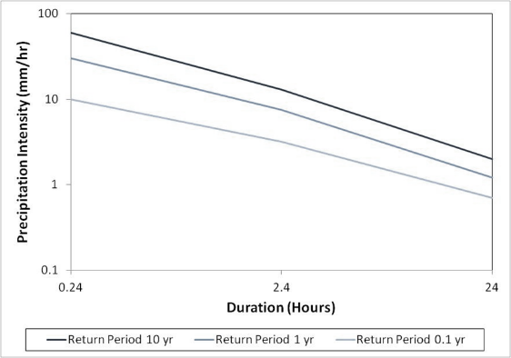
Fig. 1 The caption should be placed below the figure.
They should be referred to in the text as, for example, Fig. 1 or Figs. 1~3.
Table 1. The caption should be placed before the table.
 | A | B | C
(1) | 150 | 16.3 | 18.2
(2) | 123 | 13.5 | 16.9
(3) | 162 | 19.2

  - References

References must follow the APA style (7th edition). All sources cited in the text must be included in the reference list, and all references included in the reference list must be cited in the text.
In-text citations should follow the APA author–date system e.g. (Holland, 2004; Maetens et al., 2012).

The reference list should appear at the end of the contribution, arranged in alphabetical order by the surname of the first author. References should be written in Times New Roman, 11 pt, with consistent formatting throughout.

